Ricardo van der Heide  
359861  
[r.a.van.der.heide@st.hanze.nl](mailto:r.a.van.der.heide@st.hanze.nl)

Mockups

I have also added all mockups as a pdf file for easier reading.

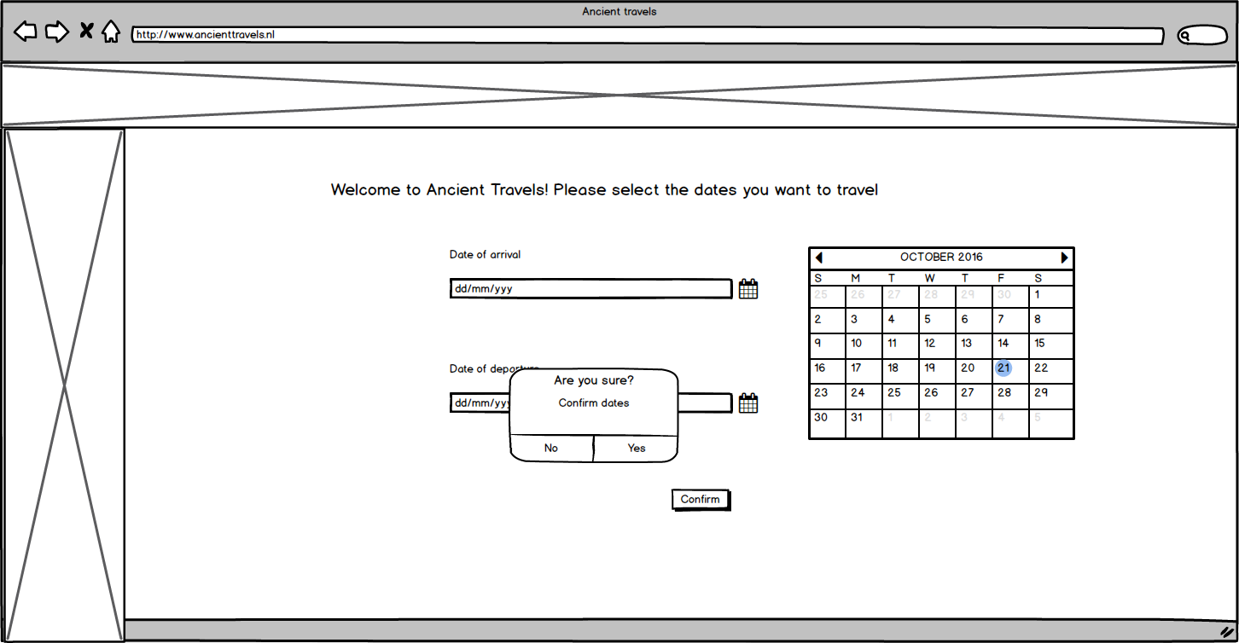

The main layout of the pages is pretty much the same;  
On top you have the site banner, which is a collage of buildings from the cities that you can travel to using this site.  
On the left side we have another banner, here we will display advertisement for the trips that are currently on sale.

There is a welcoming message on the top of the page, welcoming the consumer and asking him to set the dates for his travels.

Below that there is a text indicating that we are talking about the date of arrival  
Then we see a calendar input bar. The consumer can click the calendar icon to the right of it to bring up the calendar (as shown to the right as example). There he can choose a date, which will then appear in the calendar input bar in the format dd/mm/yyyy.

Below that is the exact same thing, but then for the departure date. Once both dates have been set, the user can click on the confirm button at the bottom.

This will make a confirmation window appear. The user can press yes to continue to the city selection.

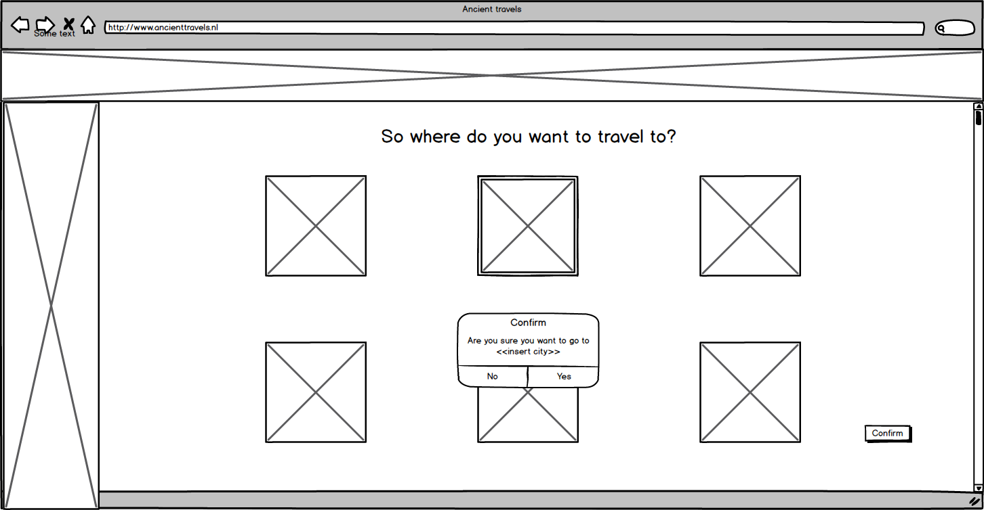

Right, so the consumer has entered the dates of his travels, but now we need to know the city he wants to travel to.   
As noted before, the banner on the left and the top are the same, as often as possible. This is to make the site feel one complete site instead of some connected pages.

When the consumer gets to this page, he is greeted by the text in the top asking him where he wants to travel.

Below that are all the possible cities he can choose from, represented by an image of a well-known building in the city.

Since the customer needs to be able to see more than just these six, a scroll bar is visible to the right of the screen to scroll down to the rest of the cities.

Once a customer has selected a city, the image representing that city will be highlighted for easy visibility.

Once the customer has decided on the city, he can press the confirm button on the bottom right of the screen.

This will make the confirmation window pop up, where the window asks for confirmation if this really is the city the consumer wants to go to. He can then click no to pick a different one, or yes to confirm the city and go on to the hotel preference window.

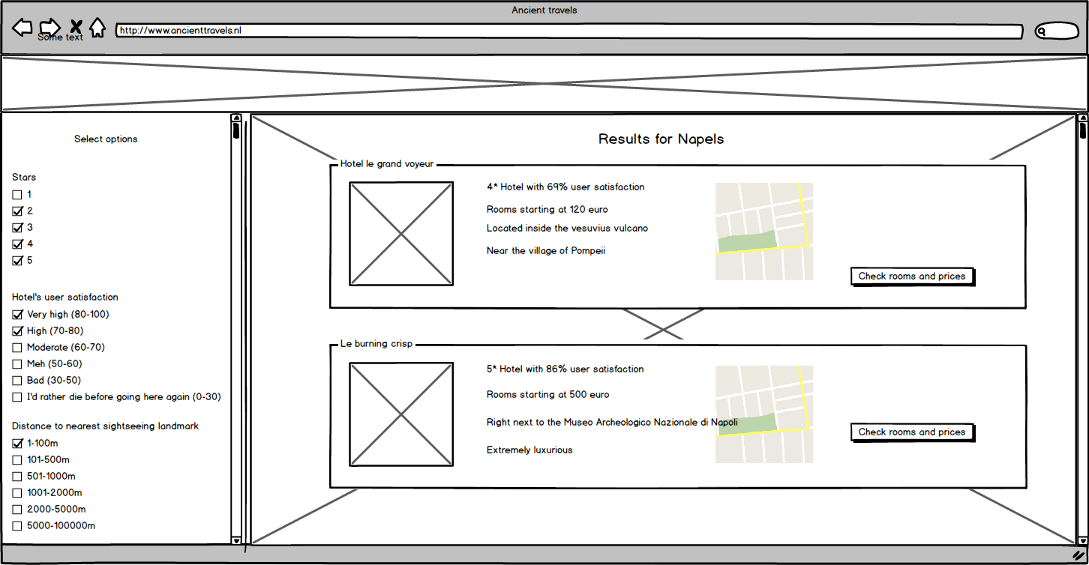

Here we have the screen for the selection of the hotel preferences.

Again, we have the top banner present with the images of the cities. This time however, we do not have the advertisement banner on the left.

On the left there are all the options a customer could want to choose from regarding hotel preferences. In this example I have added the amount of stars, the rating and the distance to the nearest land mark. There are however a lot more and they are accessible by scrolling down by using the vertical scroll bar.

The user can select all the options he wants, they’re not mutually exclusive. All the hotels that fit the preferences that the customer has selected, show up on the right side of the screen.

Because you can’t see all the hotels at once, there is a vertical scroll bar on the right of the screen.

On the background of the main screen there now is a faded image that characterizes the city. Opacity is set to 30% so the image doesn’t disturb too much.

Now we see the hotels themselves. Concise information about every hotel is visible in a rectangular shaped bar. On the left side of the bar is a photo of the hotel. Above that the consumer can see the hotel’s name. To the right of that there are 4 lines of that that give the general information about the hotel including the amount of stars it has and the rating of the hotel.

Next to that is a map indicating the position of the hotel. This map is clickable and will lead the consumer to Google Maps where he can look at more precise information about the area.

And last, there is a button that, if clicked, will take the user to the hotel and room selection page.

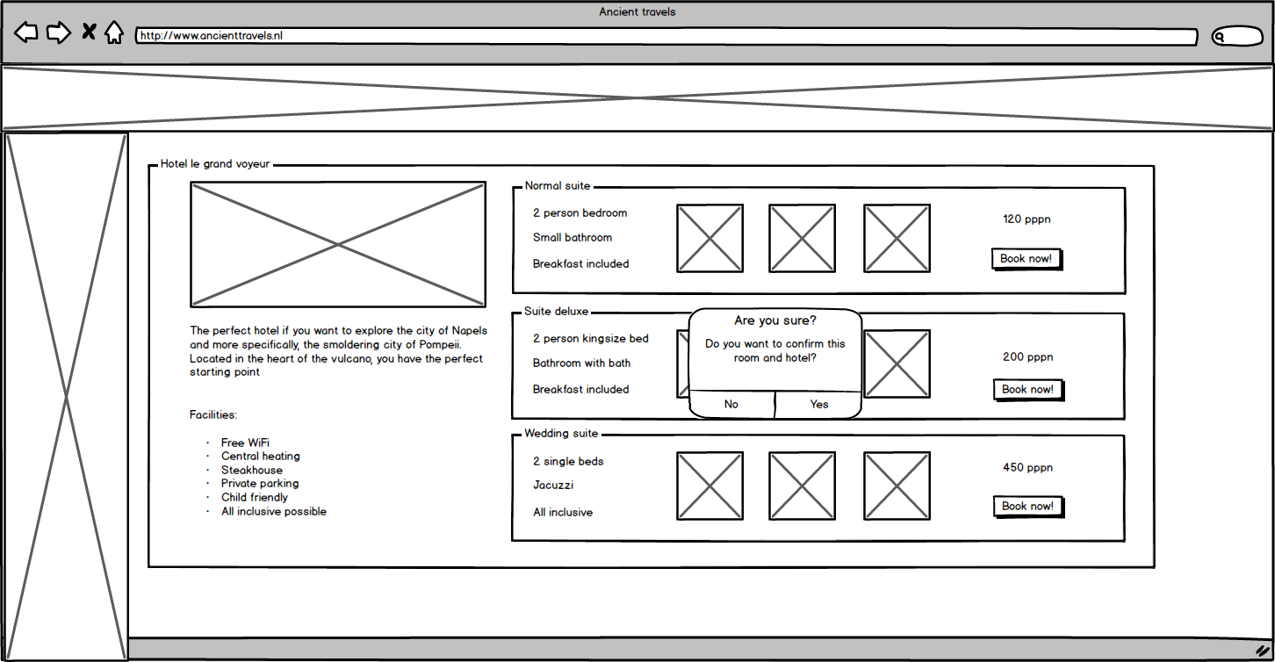

This is the hotel and room selection page. This is where the room is chosen.  
We still have the top banner as explained in all the other pages, but we also have our left banner back, since we no longer have need for the list with selectable preferences.

The main screen is the information about the hotel.

In the top left there is an image depicting the hotel. The customer can click on it and another picture of the hotel will appear.

Below that is a more precise description of the hotel. First there is a bit of text describing the position of the hotel and the general idea. To the bottom of that is a list with all the facilities the hotel has to offer. Things like WiFi, parking and if the hotel is child friendly.

Then to the right all the rooms are displayed, again in bars. On the left side of the bar we can see what kind of bed is in the particular room and a general idea of how luxurious the bathing facilities are.

To the right of the information about each room are 3 photos of the room and its facilities. More can be accessed by clicking on any of them.

Again, right of that there is the price of the room per person per night.

If the customer is sure he wants that room and hotel, he can click the ‘book now!’ button.

This will make a confirmation window appear where he can confirm the room, or go back and change his mind.

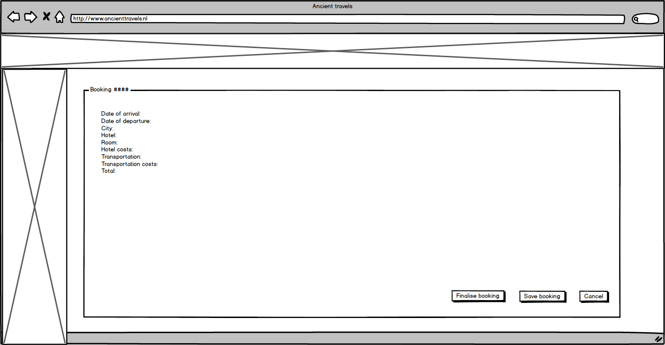

Here we are at the overview booking page. The layout is the same we’ve come to known during the last few pages.   
Again we have the banner on the top and the banner on the left.

Apart from that, there is a main area that shows all the booking options the customer has selected so far. On top the booking number is displayed for easy communication with the travel agency.

Below that is all the information: date of arrival, date of departure, the city the customer has chosen, the hotel he has chosen, the room he has chosen. Also displayed is the total cost for the hotel.  
Right below that we have the selected means of travel. The bus and flying option will be discussed in a later page. Also included is the costs for the selected travel option. And concluding comes the total cost for the selected trip.

The customer can now do 3 thing;

Finalize booking, which will bring him to the payment page  
Save booking, which will take him to the save page  
or cancels booking, which will bring him back to the beginning of the site.

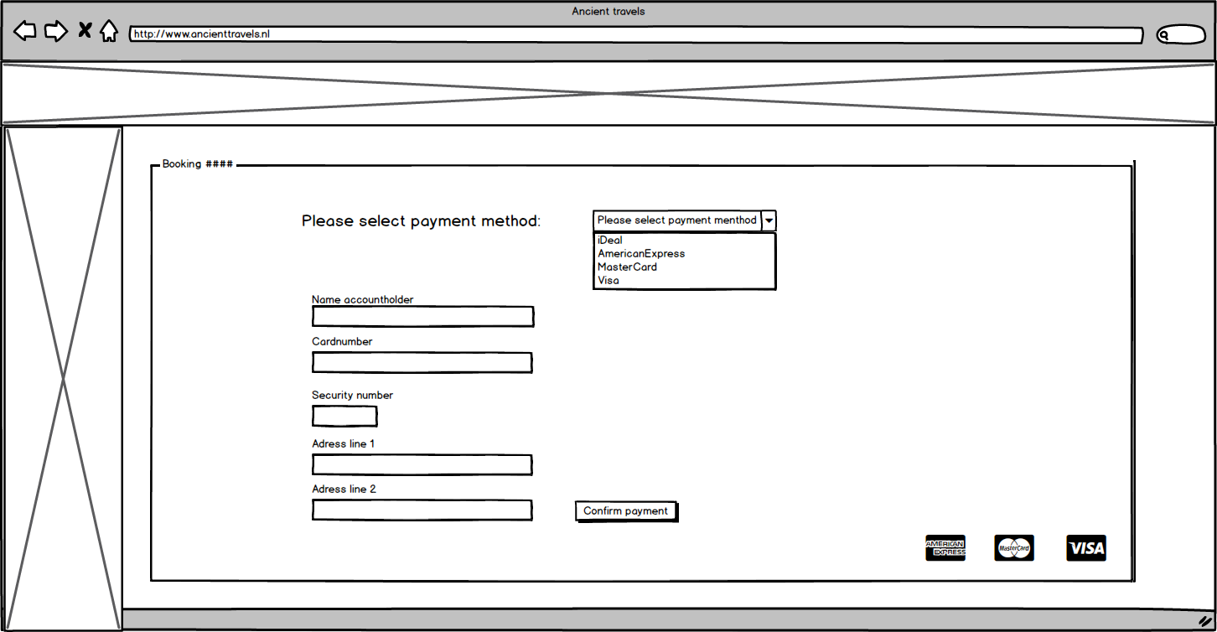

We are currently at the payment information page.  
Once again we have the banner on top with the buildings and the banner to the left with advertisements.

The main area is the payment area. On top we still have the booking plus the booking number.  
The customer is greeted with the question which method of payment he would like to use. He can then select that payment option from a dropdown menu displaying all the possible options.

Once he has selected the payment option, the customer has to fill in a form.

The top part of the form is asking the customer to enter the name of the accountholder for the selected payment option. He can then fill in his name in the field.  
Below that, the customer is asked to put in the card number for his selected payment option. He can then fill in his number in the field.  
After that we have text asking the customer to fil in the security number of his card. This is displayed on the back of his card most of the time. He can then fill in the number in the field.  
Lastly we have 2 times an area where the customer is asked for his address info. He can put in the address info in the respective fields.

Once all has been filled in , he can click the ‘confirm payment’ button, which will make the back process the payment information. The customer will be taken to the booking confirmation page if the payment was successful. If it wasn’t, he will get an error screen.

And last, in the bottom right corner are all the payment methods shown with their own logos. This makes it a bit easier to see if your payment method is accepted.

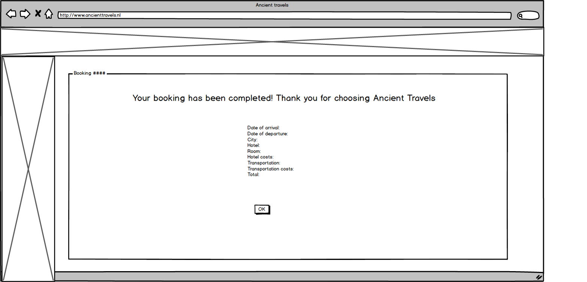

This is the last page the customer sees if the payment was successful. All information is sent to the respective agencies (airport, bus company and the travel agency).

The customer is greeted by the nice text that his booking has been completed. Then he is thanked for choosing our travel agency.

All the relevant booking info is then displayed for convenience.   
On the bottom is a button the customer can click to close the booking and go back to the front site.

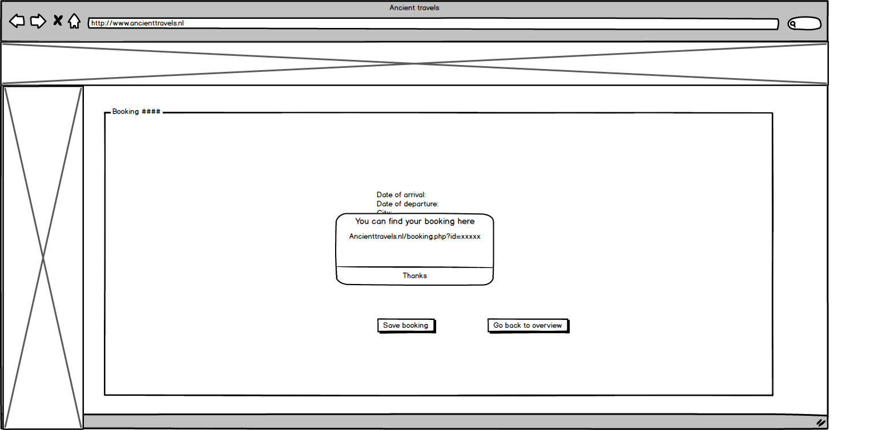

This is the save booking page.

Again, we have the top banner and the left banner.

The main area shows the booking information, the same as was displayed in the booking overview.  
below that there is a button called ‘save booking’ which will save the booking in the database and then return a window that shows the link to his booking. He can then click thanks and he will be redirected to the front page of the site.

To the right of that button is another button that says ‘go back to overview’ in case the user has decided not to save the booking after all. He will be redirected to the booking overview page.

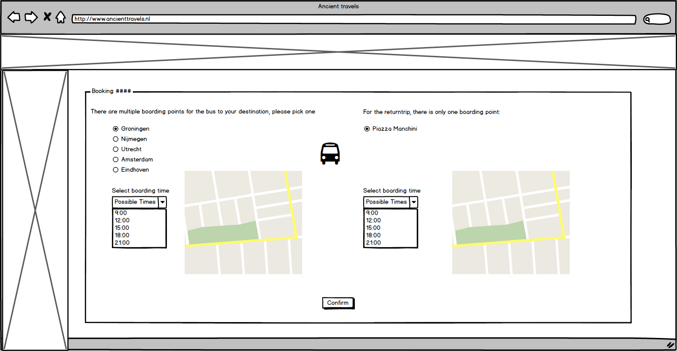

If the customer decides not to use his own car for transportation, we offer the opportunity to use the bus of an allied bus company. This is the enter boarding point page.

Again, we have the top and side banner that you are probably already fed up with by now, but Im still adding it for completion sake!

The main area shows 2 things, on the left we have the relating information the trip to the city, and to the right we have the information for the trip back home.

On the left the customer can choose the boarding point for the trip. As a standard, the option Groningen is chosen for obvious reasons.   
A bit further down the customer can select the time he wants to board the bus. In this example, he can choose from 5 different times.

To the right of this drop down menu is a map. This map changes when the customer selects his boarding point and will display the exact point the bus will stop.

A nice bus is placed in the middle top of the screen to show the customer he is on the bus page.

On the right of the screen the information for the way back is shown. Unfortunately, there is only one boarding point for the trip back home. In this case the Piazza Manchini in Napels.

Here the customer can also select the time he wants to board the bus.

Here too is a map displayed that shows the exact position of the boarding point for the bus.

At the bottom is a button called ‘confirm’ that will confirm the bus trip and takes you to the booking overview.

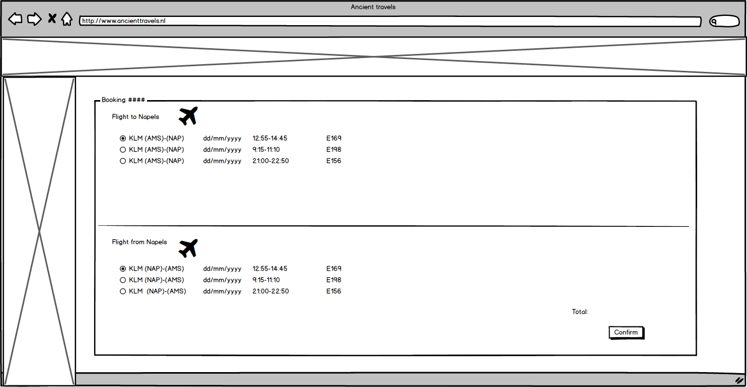

And as last, we have the display flights page.

We still have the banner on top with the buildings and the banner on the left with advertisements.

The main area shows 2 parts, the top part for the flight to your travel destination and the bottom part which displays the flights from your trip back to Amsterdam.  
The top is labeled ‘flight to << enter chosen city>>.

Next to that is an airplane depicted to make the page look a bit friendlier.  
Below that are all the possible flights possible on the day the customer wants to travel.  
The date is displayed, as well as the lift off and landing time. At the end of the line is the price displayed.

The bottom is labeled ‘Flight from <<enter chosen city>>’.  
Here there are the flights that are possible from the city, back to Amsterdam.   
They are labeled the same as the flights to the city.

At the bottom right the text ‘total’ is displayed, and behind that is the total flight cost for the roundtrip.  
The consumer can then confirm the flights and the costs by clicking the ‘confirm’ button. That will bring the consumer to the booking overview.

I realize there is no page where you can actually select the means of transportation but we were only allowed to hand in 10 mock ups so I left a few pages out.

Ricardo